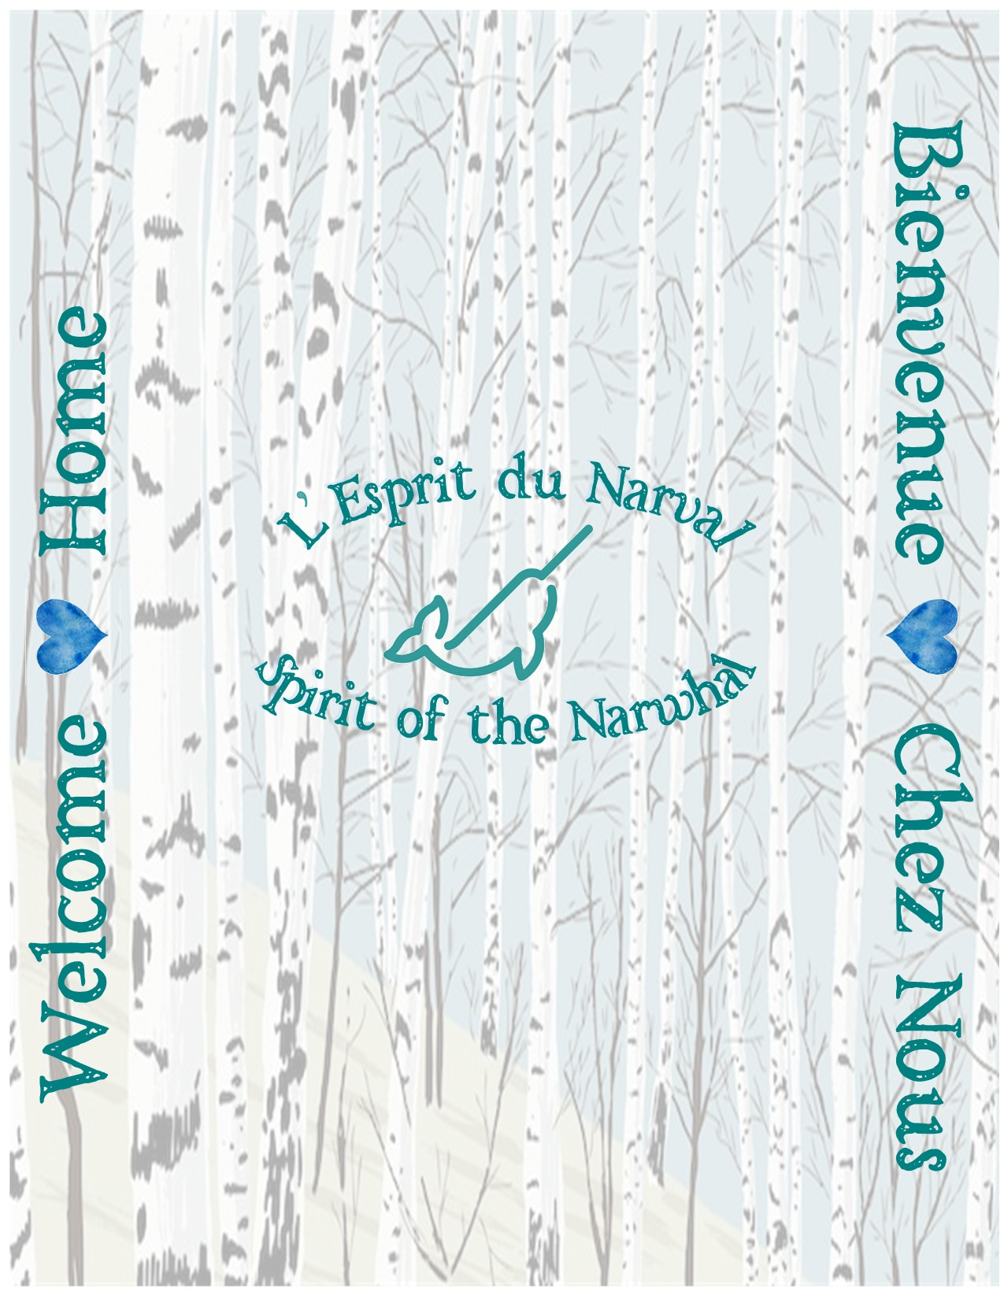
The Drive to Tadoussac (from Ontario)

- The main Quebec populations you will pass through while driving East are Montreal, Trois-Rivieres, Quebec City, Ste. Anne, and Malbaie. It’s good to plan your gas and snack stops accordingly.

- If you are expecting to arrive in Tadoussac later in the evening, consider picking up snacks and such before you arrive. The grocery store / local SAQ and gas station in town, typically close before 9pm and most restaurants will be closed earlier than you would expect. (The last McDonalds, Subway and Mike’s are in Malbaie, typically about an hour before you hit Tadoussac.)

- Also, if arriving late at night, we highly recommend getting gas in Quebec City. We have run into situations where gas stations have been closed earlier than scheduled from Malbaie to Tadoussac and all the towns between. NOTE: in the big hills you will also use more gas than you may expect.

- Between Quebec City and Tadoussac you will drive through spectacular hills, with unbelievable views and wonderful tourist spots and artisanal food, worthy of pauses where possible. During this 2+ hour section of the drive, expect cell service to get spotty until you get closer to Baie Ste. Catherine.

- Approaching Tadoussac you will come across the ferry. It typically runs every 20 minutes in peak season. Just join (or start) the lineup and they will direct you to board. The ferry is free and only about a 10-minute ride. It’s not uncommon to see a Minke whale or belugas from the ferry so if it’s nice out, feel free to get out of your car and take a look during the crossing; even without whales, the Saguenay Fjord is an intoxicating view.

- Once you get off the ferry in Tadoussac, you will be at the house in just a minute . Turn right just past the “Welcome to Tadoussac” sign. At the next stop sign, turn left. Look up, we are the white house on your left.

Arrival at the house

- The driveway is a good size so you will have lots of space to park and unload. Use the entrance at the driveway and not the door in the centre of the front of the house. The driveway comfortably fits 3 vehicles (One will be blocked in by the other 2).

- There is a keypad on the door, we will have given you your code to get in via the Airbnb app chat.
We have set the system to automatically lock again after 5 minutes.
1. Tap the pad so it lights up
2. Enter your code
3. Press the # key

- Get comfy. There are 2 bedrooms, a living room, and one bathroom downstairs, and a bedroom, bathroom, and another small living room upstairs. Downstairs, just off the kitchen near the front door, there is a bedroom with a queen bed. At the end of the downstairs hall, there is a bedroom with a double bed. There is a king bed in the upstairs primary bedroom, and the daybed in the upstairs living room is a full-size twin bed with proper 8” memory foam mattress.

- To convert the upstairs daybed for sleeping, remove the cover, fold it up and put it in the tall bathroom cabinet. There are 2 pillows in the bathroom cabinet, and a fluffy blanket to use as your bedspread. The sheets will already be on the mattress. There is a room divider screen against the wall in the upstairs living room. You can move this to the foot of the bed to give yourself privacy.

- The cabinet and hooks in the upstairs bathroom dormer are for the person who is sleeping on the daybed so that they have a place to put their belongings. There are blackout curtains on the upstairs windows, and a sleep mask for you to borrow, in the cabinet under the bathroom window.

- There are luggage racks in each bedroom, the beds are made, and we have provided towels. There are towel racks in bathrooms as well as a fold-out drying rack on the wall in the laundry room.

- You can unpack your food into the downstairs fridge & freezer; dry goods can go in (and on) the hutches across from the counter. There is also a small bar fridge with a freezer upstairs.

- Temperature Control

  - Air Conditioning:
  - Heat:
  - Other: There are portable fans in the bedroom closets, you are welcome to move them where needed.
  - Note: Feel welcome to open the windows that have screens to catch a nice St. Lawrence breeze, just please don’t forget to close when running heat or air conditioning, when it’s raining, and when you check out.

Guests with Small Children

- If you have an infant, let us know in advance and we can have the portable playpen, baby blankets, infant bath towels, and dining booster seat left out for you.

- There are toddler plates and utensils in the kitchen cabinet.

- There is a toybox of children’s activities upstairs

- In the welcome room (entry), there is a wagon for you to borrow. Walking around Tadoussac is a beautiful way to explore the village, however, it does have some hills that may be challenging for small children.

- In the wagon there is a bag of sand toys you may borrow. At low tide the beach is a fun place to visit on a nice day.

Pets
- If you are bringing a dog, let us know and we will leave out the kit containing pet dishes, yard stake with leash, dog blanket, and waste bags for you.

- We will also provide you with sheets and covers for the furniture – please use these to help cut down on the time and costs for hair removal after your departure.

- There is a bag of old towels in a black nylon bag in the tall laundry room cabinet. If you need something to clean pet paws or messes, please use these and then leave what you use on top of the washing machine so we know they need cleaned.

Helpful Amenities

- In the welcome room you will find umbrellas as well as a basket of warm hats, some gloves, and scarves. Please feel free to borrow these items if you need them (it’s quite a bit cooler on the river than you might expect). At the end of your visit, you can leave the hats, gloves, and scarves you used on top of the washing machine, and we will clean them for the next guests.

- Food and supplies – There is a small but generally well-stocked grocery store in the village. It has produce, meat, packaged food, frozen food, dairy, alcohol, and some hygiene products. We have some reusable bags in the welcome room, you may borrow these for your grocery trips. The store is just a few hundred metres away at 243 Rue des Pionniers, Tadoussac. At the end of our street, turn left at the stop sign, walk down the hill past the gas station, a couple of great restaurants and the bank - the store will be on your left up the white stairs. (Helpful hint: if you are walking to the store, be prepared for the walk back uphill with your groceries.)

- We have excellent Wifi that can easily support multi users and video calls. You will find the network name and password on the fridges both downstairs and up.

- A basic sewing kit can be found in the upper cabinet in the upstairs bathroom cabinet next to the sink.

- The kitchen is stocked with many items including: pots, pans, dishes, utensils, wine and water glasses, crockpot, toaster, kettle, coffee maker, microwave, and a dishwasher. Dish soap and dishwasher tabs are provided. There is a drying mat and dish drying rack in a lower cupboard to the right of the sink.

- Now and then we are able to gift homemade waffles in the Kitchen freezer for your enjoyment. Should you be staying at time when we have been able to replenish, warm them in the oven (250 degrees for 10 minutes) for a tasty treat. Sirup, coffee, filters, tea, hot chocolate are also provided. You are welcome to use any condiments in the fridge again, the store has many items you may need.

- Do you need to check in with work? There are 2 desk workstations in the house. One is upstairs situated in the living room dormer and has a lovely view of the fjord hills. The second one is in the downstairs back bedroom for more privacy.

- You may use the washer and dryer as needed. There are containers with laundry soap and softener in the laundry room. The “normal” or “quick wash” cycles will work well for most of your needs.

- Shampoo, conditioner, bodywash, cotton balls, tissues, toilet paper, and Q-tips are provided in each bathroom. There are extra rolls of paper towels and toilet paper in the upstairs bathroom cabinet.

- Please feel welcome to use the provided bath robes and slippers. They can be found in each bedroom closet.

Safety

- ALLERGY ALERTS
  - We are a pet-friendly home. Although we uphold a high standard of cleaning between guests, if you have pet-related sensitivities we cannot ensure you will not be affected.
  - The sofa in the downstairs living room has feather fill.
  - The previous owners of the house did smoke inside. Although over the past 3 years we have cleaned and renovated extensively, someone with exceptional sensitivity may still be affected.
  - Seafood of all kinds is common in our surf-side village, therefore, many kinds of shellfish are cooked in our kitchen.
NOTE: We do not allow smoking of any kind indoors at all!
Please be respectful of this rule, our efforts, our family, and our other guests.

- The tap water is potable.

- Please use the plastic patio glasses for use out on the deck. They are on the shelf over the microwave.

- A first aid kit is in the laundry room cabinet.

- Fire extinguishers are positioned on both levels of the house. There is one upstairs by the microwave, one downstairs under the kitchen sink, and one in the laundry room.

- The house has stairs in front of every entrance, as well as up to the second floor. Please be very mindful and cautious with any members of your group who may have mobility challenges.

About the House

- Our home is used by our family when guests aren’t booked in, so please know that it’s a well-loved space. The neighbourhood and village are very family oriented with a focus on nature and local resources. Please conduct your stay respectfully for our neighbours and fellow residents.

- The stairs to access the upper level are off the laundry room near the patio door that leads to the deck.

- Garbage and recycling bins are under the kitchen sink. When they get full you can empty them into the large bins at the back of the house. Alcohol cans and bottles can go right into recycling. The recycling bin is blue, everything else goes in the green bin. We don’t have compost bins.

- If you have a spill or mess, there is a bag of old towels in the tall cabinet in the laundry room. The bag is black and says “laundry” on it. You can use these to clean up any spill and then just put them back in the bag and leave it on top of the washing machine for cleaning. Please do not use our good towels for large or stain-causing messes.

- As nature lovers, we enjoy having our bird feeders. If the feeders happen to be empty and you would like to try and attract backyard birds, there is a container of bird seed mix on the upper shelf in the welcome room.

- Bedrooms are guest-ready with fully dressed memory foam mattress beds, hangers, luggage racks, towels, end tables, and lamps. Towels for upstairs guests are in the bathroom cabinet.

- While water pressure is fine in the house, but you may notice a drop in pressure if both showers are used at the same time and/or toilets are flushed at the same time.

- Our hot water tank has good capacity (typical size for a family of 4) but may not hold temp through several back-to-back showers. Please use your best judgement to ensure enjoyment for all; it’s best if you space out usage.

- The downstairs fireplace can be turned on using the white remote with red button on the coffee table. Please be sure to turn it off once temperature is comfortable. Propane here is pricey.

Entertainment

- There are yard games and outdoor blankets in bins in the laundry room, you are very welcome to use them to enjoy the backyard and deck. If you have kids (or just want to doodle yourself), there is a bucket of sidewalk chalk in the laundry room as well. The back portion of the driveway as well as the big granite rocks in the backyard are just waiting for complimentary works of art.

- Indoor board games can be found in the coffee table drawer in the upstairs living room, as well as the toybox for small children.

- The TV’s have Roku so that you can sign into your own favourite viewing platforms.

- It’s not uncommon for the Village to be hosting a festival or special event. Check the Tadoussac tourism website to see what may be happening (https://tadoussac.com/). Every Saturday morning through the summer, there is a small farmers and crafters market in the church parking lot across from the general store just down the hill of the main street. It’s worth checking out for fresh produce and local artwork and crafts.

- There are many lovely restaurants in the village. If you want to take a break from cooking, just stroll around and see all the options from simple fare to world-class. Most have menus and prices posted outside so that you can make a decision before you commit.

- The village has 800 full-time residents, but in peak tourist season, it can be up to an additional 1500 people a day. Be aware that restaurants could be crowded or have a wait time. We have our best luck in dining at off-peak hours with a late lunch or early dinner to avoid the rush.

- There are lots of neat attractions in the area.

  - Great hiking trails in a variety of terrains
  - visit the sand dunes
  - The Marine Mammal Museum
  - The trading post
  - North America’s oldest wooden church
  - The boardwalk around the water gives nice views of the river and shoreline. You can access it by walking out towards the pier and taking the path off to your right across from the back of the Bistro on the Baie. It’s not uncommon to be able to view Minke whales and belugas from the shore, as well as a variety of seabirds.

Whale tours

- In the village of Tadoussac the largest tour provider is AML, with several boats and cruise options. Their outfitting office is across the road from the marina docks next to the big gravel parking lot and the Interpretation Centre, with several ticket agencies around town. https://www.croisieresaml.com/en. Another excellent cruise company is Tadoussac Autrement. They have a single covered boat and board from the beach. https://www.tadoussacautrement.com/ (More information on them below.)

- Some quick tips on AML options: There are 2 types of tour vessels, the small zodiac, and the large 3-decker cruising boat. If you are comfortable on the water and are fine with some splashing and sometimes bumpy ride (conditions dependent), we recommend the zodiac. It gives you a much closer view of the whales and you will generally see more and see better than the big boat. They will give you splash suits to help keep you dry. The big boat is dry, warm, and has a full snack bar as well as bathrooms. The big boat is often crowded, so find a spot at the rail as best as you can.

- The different types of AML vessels are generally the same cost, about $115. Tour guides are bilingual. You can easily buy tickets online by going to the AML website. You will need to be at your tour a half hour before departure. Tours typically run at 10am and 1pm, and one at 4pm on some days. There are also dinner, sunset, and river cruises. Most tours from Tadoussac will also take you briefly into the mouth of the fjord for a spectacular view.

- If you choose the zodiac, we recommend taking sunglasses to keep water and glare out of your eyes, a warm hat (as it can get chilly) and wear waterproof footwear (I wear hike boots or rubber boots), and a warm sweater. Even in July and August, it can be chilly on the water. Remember, Belugas like it here…the water is about 4 degrees Celsius year-round, the breeze is coming off the ocean, and the boat moves pretty quickly. It’s a good idea to have a waterproof cover for your phone if that’s what you are using to take pictures. Electronics do not like salt water.

- There is another whale tour company in Tadoussac called “Tadoussac Autrement”. Their boat is a bit bigger than a zodiac but has a covered section to protect you from the elements. Windows open wide once you are at a whale viewing sight. It only seats about 30 people so you will need to try and book as soon as you can. The tour guides are bilingual. The ride can be rough like a zodiac but it is a good option should you like a smaller crowd and less exposure to elements. Please know that it is still chilly so dress appropriately. There are no bathrooms on board. This tour leaves from Tadoussac beach near the kayak rental booth. The boat is black and red so you can easily tell them from the yellow boats belonging to AML.

- If you are going for a whale tour, we highly recommend walking down from the house as parking is VERY crowded and you will need to pay. We often do the afternoon tour instead of the morning tours as fog and weather often clears after lunch. Check your weather often and plan accordingly.

- In the town of Les Escoumins we have found another great tour company and they have a lower priced option for a zodiac whale tour. This is about 20 minutes up the coast and Zodiac tours there are about $65 BUT they book up fast. If you know your schedule and want to do this option, book as early as possible. This tour company has more time options. They provide a jacket for warmth but NOT a splash suit, so we recommend bringing rain/splash pants and a wind breaker to wear under the provided coat to keep you dry. You will need a warm hat and waterproof footwear on this tour as well. Please note that to board this zodiac there is a very steep ramp going down to their docks. If you have any mobility challenges, this may be difficult for you to navigate. https://croisierebaleine.ca/.
Village of Tadoussac

- The primary language in the village is French. That said, during peak tourist season (June to late August), it’s not uncommon to find customer service staff who speak English in local establishments. In off-peak months, establishments are mostly run by locals and English gets to be less common. Please be patient, ask for someone who speaks English, and respect local culture. They will try and accommodate you as best as they can. Using Google translate and showing them your phone is helpful in situations where language barrier is a challenge.

- If you are vacationing in Tadoussac in mid-September and later, please know that it’s not uncommon for local restaurants and shops to start closing for the season. Be aware that there are still many tourists and whales into the fall, but town resources start to dwindle.

- The house is within close proximity to everything in the village. Parking by the water is quite a challenge to find, therefore we highly recommend walking to your attractions whenever possible.

- E-Car charging stations can be found in the small parking lot at the bottom of our street, and across the intersection down the hill.

The Surrounding Towns
- Sacre Coeur is about 10 minutes from Tadoussac. It has a Home Hardware, a small Rona, a very small pharmacy, a good size grocery store, and a small multipurpose “Giant Tiger-like” place called “Rossy”.

- Les Escoumins is about 30 minutes from Tadoussac. It has a large pharmacy, grocery store, fresh fish market and attached restaurant (https://poissonnerieescoumins.com/ ), 2 large hardware stores, and 2 small whale tour providers.

- About 15 minutes further up the coast from Les Escoumins there are 2 pretty road-side waterfalls with a small suspension bridge and hike trail. This spot is called The Parc de la Chute de Sault au Mouton.

House Rules

- Our home is a non-smoking environment. Please smoke outside and stay clear of open windows so smoke doesn’t transfer inside. A cigarette butt canister can be found just off the back deck.

- Please protect our new floors and minimize mess by removing your shoes in the welcome room and refrain from moving furniture.

- If you have a spill or mess, there is a bag of old towels in the tall cabinet in the laundry room. The bag is black and says “laundry” on it. You can use these to clean up any spill and then just put them back in the bag and leave it on top of the washing machine for cleaning. Please do not use our good white towels for big messes.

- There are thermostats in every room to help you customize the temperatures in your space, however, please do not set any temps past 22 degrees, most rooms will easily heat beyond this temperature without turning up the heat. It can get quite warm especially in smaller rooms, and there is no air conditioning to cool excess heat.

- A video camera with the ability to record audio is positioned at the front of the house in the doorbell to provide peace of mind and security to your, and our, family. No spaces inside the home are recorded in any way. Tampering with any video equipment will result in termination of your stay and could come with extra charges to the guest should conduct result in damage to equipment.

- We are very happy to welcome your well-behaved pets. You will find a kit for dogs on the shelf in the Welcome Room. In this box you will find bowls, waste bags, and a blanket. You will also find sheets which need to be used to cover the couches and chairs to help reduce the extra time (and costs) required by our cleaners to prepare the house for the next guests.

- If you are travelling with cats, please let us know, we may be able to accommodate you with a litter box and cat tree. Placing sheets from the pet kit onto the furniture is a good idea to keep things easier for our cleaners.

- Children of all ages are welcome. Please let us know if you are travelling with an infant as, on request, we can provide a portable playpen with blankets, infant towels, a booster seat with tray for meals, and children’s books and toys. Please note that we have not child-proofed our home.

- Quiet hours are between 10pm and 7am.

- There are beach towels and some beach toys with the wagon in the welcome room. Please don’t take our white bath towels to the beach. If you use the beach towels, please put them in the laundry room so that we know they have been used and need washed for the next guest.

- Notify us of anything broken or out of place so that we may do our best to correct the situation for you as well as next guests.

- No parties

- Tampering with or disconnecting Wifi will result in termination of your reservation without refund.

- The property boundary to the north side of the house has been marked with flagging stakes. Please respect the boundary out of consideration of our neighbours.

Fire pit
Before doing anything with fire, please check the fire ban status at: https://sopfeu.qc.ca. Look for alerts on the main page and enter Tadoussac in the “Location” box.
- We get very strong winds from the fjord across our back yard. Do not build a fire on windy days – gusts can easily make the fire get away from you.
- Ensure you have a pail of water next to your fire. A metal pail for extinguishing water can be found in the small shed behind the garage.
- If the province permits a fire, please also think of safety for the house.
- Do not place the fire pit on the deck, or near the house or garage.
- If the fire pit is not already out on the yard, you will find it under the deck.
- If we have any wood available from house projects and land maintenance, it can be found on the wood rack against the garage wall. There are also places around town (and on the road to town, including the village store) where you can buy a bag of wood.
- As always, ensure the fire is completely extinguished before leaving it unattended.
- A barbeque lighter and marshmallow roasting holders, can be found in the cabinet over top of the washing machine in the laundry room.

Check-In
- Check-in is any time after 4pm
- Your door code will be the last 4 digits of the phone number you used for the reservation. It will be active as of 4pm on your day of check-in.

Check-Out
- Check-out by 11am
- Late check-out fee is $75 per hour due to the extra work involved for cleaners to properly do the turnover for the next guests.
- Please put dirty dishes in the dishwasher and start it. Dishwasher pods are under the kitchen sink.
- Leave used beds unmade with the sheets on.
- Used towels can be piled in the bathtubs.
- Ensure all windows and doors are closed and locked
- Please take all food that you brought.
- Please empty your garbage and recycling into the large bins at the back of the driveway.
- Turn off lights and ensure fireplaces aren’t running.

Indoor Fireplace Instructions

- Downstairs fireplace – The white remote with red button on the coffee table will turn on the fireplace. Please remember to turn it off when room is to temp or before you leave the house.

- Upstairs fireplace – push the red power button to turn on the fireplace. Push the button with the picture of the thermometer to turn on the fan that will blow heat into the room. This fireplace doesn’t have a thermostat so remember to turn it off when the room is warm enough.

Laundry
- A modest amount of laundry soap and fabric softener has been left for you to use. For longer stays you may want to wash some clothes or the provided towels. The “normal” cycle setting on the machine works very well for most loads.

- To add soap and softener, pull out the “drawer” to the left of the settings knob. Soap goes in the well on the left, softener goes in the well on the right.

- Please don’t use bleach. Should you have a stain you are trying to remove, there is stain spray and vinegar on the top shelf in the cabinet across from washing machine.

Light Switches
We have installed some smart switches and lights, and some of them have unintuitive programming. If you are interested in what the programming is, here are the details…

Front wall of kitchen, near door
Downstairs Lights – Low
Downstairs Lights – Bright
Accent Lights
Main Lights

Switch at Kitchen Sink
Overhead Sink Light
Short Press: Kitchen Lights On
Long Press: Kitchen Lights Off
Special TV/Theatre Lighting

Hallway Switch
ON: Turns on Hall and Kitchen Potlights – Low
OFF: Turns off all downstairs lights

